**RECOMMENDATION SYSTEMS**

1. What is Text Recommendation?

A text recommendation engine can be understood as a similarity optimization problem. In a vector space, this translates to finding the closest point for a set of initial conditions.

**(OR)**

Text recommendation, also known as text-based recommendation, refers to the process of suggesting or recommending textual content to users based on their preferences, interests, or contextual information. It involves analyzing text data and generating recommendations that match the user's needs or provide relevant information.

1. How the Text or Article Recommendation works?

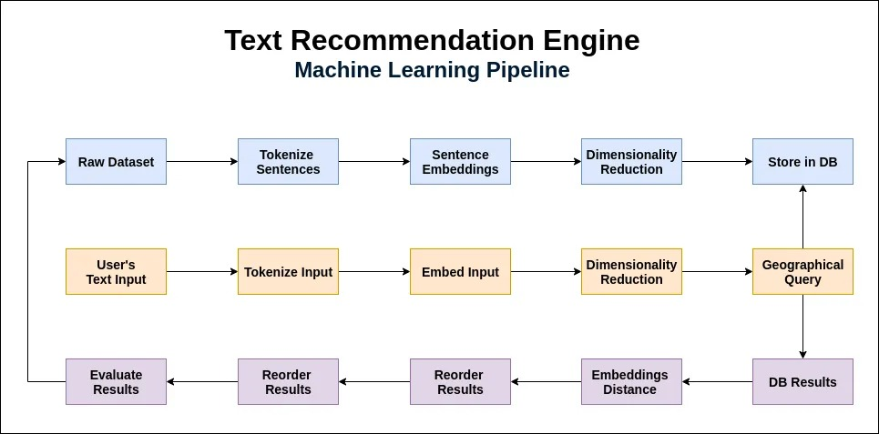

Above figure shows us the pipeline of how it works

A text or article recommendation system works by analyzing user data and textual content to provide personalized recommendations. Here's a general overview of how such a system operates:

1. Data Collection: Gather data from various sources, including user interactions (e.g., clicks, ratings, searches), user profiles (demographic information, preferences), and textual content (articles, blogs, documents).
2. Data Preprocessing: Clean and pre-process the collected data by removing noise, normalizing text, and extracting relevant features such as keywords, categories, and sentiment. This step prepares the data for further analysis.
3. User Profiling: Build user profiles based on their past interactions, preferences, and demographic information. User profiles can capture interests, behavior patterns, and other relevant characteristics.
4. Content Representation: Represent the textual content using techniques like TF-IDF (Term Frequency-Inverse Document Frequency), word embeddings (e.g., Word2Vec, GloVe), or more advanced models like BERT (Bidirectional Encoder Representations from Transformers). These representations capture semantic meaning and similarity between articles.
5. Recommendation Algorithms:

a. Content-Based Filtering: Recommend articles that are similar to the ones a user has engaged with in the past. Calculate similarity scores between articles based on their content representation and suggest those with the highest similarity.

b. Collaborative Filtering: Identify similar users based on their article preferences and recommend articles that similar users have liked or engaged with. This approach utilizes user-user or item-item similarity calculations.

c. Hybrid Approaches: Combine content-based and collaborative filtering techniques to leverage the strengths of both methods. This can improve recommendation accuracy by considering both article content and user behavior.

d. Etc.

1. Machine Learning Models: Train machine learning models using historical data to predict user preferences or article relevance. Techniques like matrix factorization, deep learning (e.g., neural networks), or reinforcement learning can be employed to learn patterns and make better predictions.
2. Evaluation and Optimization: Continuously evaluate the performance of the recommendation system using metrics like precision, recall, click-through rate, or user feedback. Optimize the system by refining algorithms, features, or user profiles based on the evaluation results.
3. Integration and Deployment: Integrate the recommendation system into the platform or application where it will be used. Monitor its performance, scalability, and user satisfaction, and make necessary adjustments to ensure optimal functioning.
4. Different Algorithms that can be used?
5. Content-Based Filtering: This approach recommends articles based on their content similarity to the user's past interactions or preferences. Techniques like TF-IDF (Term Frequency-Inverse Document Frequency) and word embeddings (e.g., Word2Vec, GloVe) are used to represent the articles and calculate similarity.
6. Collaborative Filtering: Collaborative filtering recommends articles based on the preferences of similar users. It can be further divided into two types:

a. User-Based Collaborative Filtering: It finds similar users based on their past interactions and recommends articles liked by those similar users to the target user.

b. Item-Based Collaborative Filtering: It identifies similar articles based on user interactions and recommends articles similar to the ones the target user has engaged with in the past.

1. Hybrid Approaches: These methods combine multiple recommendation techniques, such as content-based filtering and collaborative filtering, to improve recommendation accuracy. For example, content-based filtering can be used to augment collaborative filtering by incorporating article content similarity.
2. Matrix Factorization: Matrix factorization techniques, like Singular Value Decomposition (SVD) and Alternating Least Squares (ALS), factorize the user-item interaction matrix to identify latent features and make recommendations based on those features.
3. Neural Networks: Deep learning models, such as Recurrent Neural Networks (RNNs), Convolutional Neural Networks (CNNs), and Transformer-based models (e.g., BERT), can be applied to capture complex patterns in article content and user behavior for recommendation.
4. Reinforcement Learning: Reinforcement learning algorithms can be employed to optimize article recommendations by directly interacting with users and learning from their feedback. It involves learning a policy to select articles that maximize user engagement metrics.